# Project Report

|  |  |
| --- | --- |
| **Product Name** | Advanced Certificate in Web Development |
| **Qualification Name (ITSF)** | NICF-Advanced Certificate in Infocomm Technology (Software & Applications) |
| **Product Name** | NICF-UI Frameworks |
| **Module Name (ITSF)** | NICF-UI Frameworks |

|  |  |  |  |
| --- | --- | --- | --- |
| **Student name** | | **Assessor name** | |
| Wildan Luqmanul Hakim | |  | |
| **Date issued** | **Completion date** | | **Submitted on** |
| 13 July 2022 | 16 July 2022 | | 16 July 2022 |
|  | | | |
| **Project title** | **Design & Develop Front End Community Portal RIA application.** | | |

|  |
| --- |
| **Learner declaration** |
| I certify that the work submitted for this assignment is my own and research sources are fully acknowledged.  Student signature: Wildan Date: 16 July 2022 |

**Content**

1. Project background
2. Project Objectives
3. Business Process & Solution Architecture
4. Task 1
5. Task 2
6. Task 3
7. Task 4
8. Task 5
9. Task 6
10. Task 7
11. Task 8
12. Task 9
13. Task 10
14. **Project Background**

ABC Jobs Pte Ltd is a website development company, this company has a new project to develop a website for Community Portal similar to Linked.in, in this project ABC Jobs requires a scenario for users to register on the registration page, users can search for other users with various parameters such as First Name, Last Name, Company Name, City and Country. Users will be able to view the Public Profile of users after searching them. The portal allow users to login, request for forgotten password and Update their profile information.

In the project in this module to develop a GUI front end using HTML, CSS, JavaScript, and Angular

1. **Project Objective**

The portal consist of the following Key pages (For Reference)

1. Community Portal Home Page
2. Registration Page
3. Registration Confirmation Page
4. Update Profile Page
5. Search Users Page
6. List Search Results
7. Public Profile Page
8. Registration Confirmation Email
9. Login Page
10. Forget Password Page
11. Design the Forget Password Confirmation Page

Tools & platform used

1. Visual Studio Code
2. Google Chrome
3. Angular CLI
4. Axure RP 10
5. Microsoft Words
6. Microsoft PowerPoint
7. **Business Process & Solution Architecture**

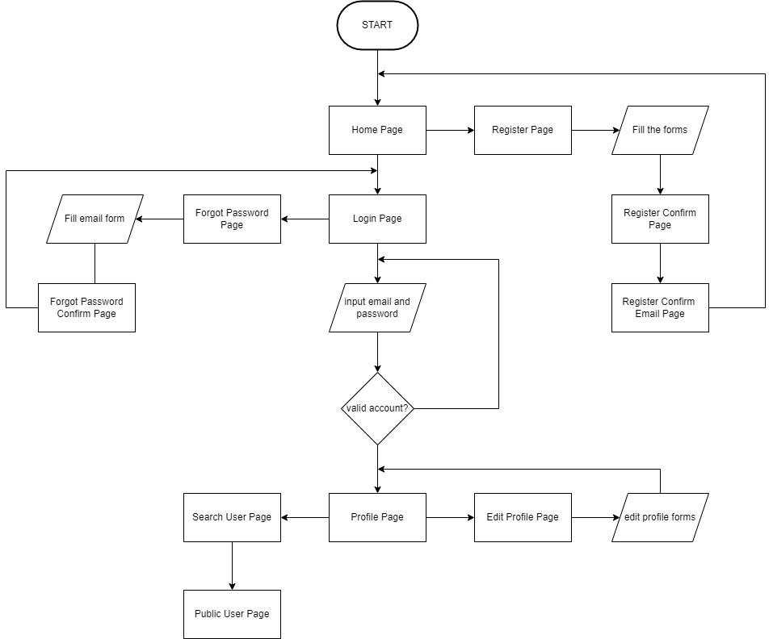

Starting with the home page, users can register to the register page, then fill out several forms on the register page, after registering will be directed to the register confirm page and will be redirected to the register confirm email page, after creating an account, the user can log in using the login form provided on the home page or go to the login page.

Then the user can enter the email and password that was registered earlier, after that click login and will be directed to the profile page, but if the user forgets the password can go to the forgot password page, then enter the registered email and click reset password, after that it will be directed to forgot password confirm page.

After the user enters the profile page, the user can edit the profile as desired to the edit profile page, and change the form to be edited, then click the edit button, if the user wants to see other users can go to the public page in the navbar and the user will see list of other users and can search for other users specifically by first name, last name, company name, city and country, and users can see the profiles of these other users

1. **Task 1**

**Task Statement:**

1. Briefly explain techniques and methods for gathering and analysing user feedback.
2. Find at least 2 websites which are similar to community portal and visit and use them and record your experiences.
3. Include it as part of **Project Presentation**

**Solution:**

Qualitative research is the process of collecting, analyzing, and interpreting non-numerical data, such as language. Qualitative research can be used to understand how an individual subjectively perceives and gives meaning to their social reality.

Quantitative research involves the process of objectively collecting and analyzing numerical data to describe, predict, or control variables of interest.

**Experience on 2 community portal websites**

1. Linkedin.com

I visited the LinkedIn website and, when on the main page it looked interesting, because LinkedIn has a simple and attractive appearance, I tried to register my account, on that page it is very simple, only requires an email and password to register an account, even can use an account google, then I tried to login and the login screen is also simple and interesting because it only requires an email and password, just like the register page

1. Indeed.com  
   I have visited the Indeed website, it looks simple but not attractive, because on the website there is no image so the appearance is less attractive, even I think the color combination on the Indeed website is also less attractive, it can be said that it is too simple, I tried to register my account, and the register and login pages are combined there, there is only an email form to register and login, and can also use a google, apple, or facebook account, it makes it easy for users to register and enter the Indeed website

## Task 2

**Task Statement:**

1. Discuss, study and analyze the user experience based on the observations done in Task 1.
2. Study the experience for 2 to 3 scenarios.
3. Include it as part of **Project Presentation**

**Solution:**

1. Login Page

LinkedIn login page looks interesting because of the appropriate color combination and there is an animation when we want to enter an email and password and we can display the password to login, and there is a warning when the login button is pressed but the email and password have not been entered, while Indeed looks simple and easy. , but there are no animations and less attractive color combinations, there are warnings as well as LinkedIn.

1. Register Page  
   Registering on LinkedIn is quite difficult because we have to fill in data that needs to be filled in such as whether we are students or are already working, the display on LinkedIn looks attractive and it is easy to fill out the required form, while Indeed has a less attractive appearance but when logging in it will be very easy because we only need to use email, then a verification code will be sent but if you use google it will be directly connected so there is no need to verify the code, and the account is ready

## Task 3

**Task Statement:**

1. Identify the performance level & gaps between user experience & desired user experience along with level of user engagement
2. Measure the level of user engagement & stickiness with the product.
3. Document it as part of **Project Report.**

**Solution:**

|  |  |  |  |  |
| --- | --- | --- | --- | --- |
| **LinkedIn.com** | | | | |
| Scenario | TOT (seconds) | Expect TOT | Performance Gaps | UER |
| Register | 65 | 60 | 65 | 2 |
| Login | 18 | 20 | 2 | 0 |
| **Indeed.com** | | | | |
| Scenario | TOT (seconds) | Expect TOT | Performance Gaps | UER |
| Register | 50 | 60 | 10 | 0 |
| Login | 30 | 20 | 10 | 2 |

## Task 4

**Task Statement**

1. Develop & document 3 metrics to measure the user experience.
2. Create Bootstrap HTML along with angular pages for the proposed pages and get feedback from mentor and document them.
3. Document it as part of **Project Presentation.**

**Solution**

Included in the project presentation

## Task 5

**Task Statement**

1. Create the steps in User Interaction process for various scenario.

2. Create a flow chart for user interaction.

3. Document it as part of **Project Presentation.**

**Solution**

Included in the project presentation

## Task 6

**Task Statement:**

1. In the Websites study’s get the general user response from one other user.

2. Document the general user response to the product as part of **Project Presentation.**

**Solution**

Included in the project presentation

## Task 7

**Task Statement**

1. Create a Prototype for the proposed system, with at least 5 screens

2. Get the user response and classify them to various types.

3. Screen capture the prototype and include it as part of **Project Presentation.**

**Solution**

Included in the project presentation

## Task 8

**Task Statement**

1. Gather feedback for the prototypes and document, make suggestions for improvement.

2. Make suggestions to improve the user experience and implement them in the prototype

3. Include it as part of **Project Presentation**

**Solution**

Included in the project presentation

## Task 9

**Task Statement**

1. Create 3 usability tests and test them with users.
2. Get the users use the modified prototype
3. Gather feedback and measure its technical viability and effectiveness
4. Include it as part of **Project Report**

**Solution**

|  |  |  |  |  |  |
| --- | --- | --- | --- | --- | --- |
| **Task: Register for an account** |  |  |  |  |  |
|  |  |  |  |  |  |
| **Participant Name** | **TOT (seconds)** | **UER** | **TSR** | **Observation** | **Feeback** |
| Dimas | 30 | 0 | Success | No Issue | Excellent |
| Achmad | 50 | 1 | Success | Can’t see password | Add show password |
| Rivan | 20 | 0 | Success | All Good | Great |
| Sabar | 55 | 2 | Success | Good | Add check button for Terms of Service |
| Dandy | 20 | 0 | Success | Easy to Fill | - |
|  |  |  |  |  |  |
|  | **TOT** | **UER** | **TSR** |  |  |
| **Average Score** | 35 | 12% | 100% |  |  |
|  |  |  |  |  |  |
| **Analysis & Suggested Improvements** | |  |  |  |  |

1. User can’t see the password has been typed, will make show password button
2. User need to check for Terms of Service

|  |  |  |  |  |  |
| --- | --- | --- | --- | --- | --- |
| **Task: Login with account has been registered** |  |  |  |  |  |
|  |  |  |  |  |  |
| **Participant Name** | **TOT (seconds)** | **UER** | **TSR** | **Observation** | **Feeback** |
| Dimas | 19 | 0 | Success | Invalid Email | Add warning form |
| Achmad | 15 | 1 | Success | Can’t see password | Add show password |
| Rivan | 14 | 0 | Success | All Good | Great |
| Sabar | 12 | 0 | Success | No Issue | Nice |
| Dandy | 20 | 1 | Success | Wrong Password | Add show password |
|  |  |  |  |  |  |
|  | **TOT** | **UER** | **TSR** |  |  |
| **Average Score** | 16 | 8% | 100% |  |  |
|  |  |  |  |  |  |
| **Analysis & Suggested Improvements** | |  |  |  |  |

1. Make show password button
2. Add warning for email and password form

|  |  |  |  |  |  |
| --- | --- | --- | --- | --- | --- |
| **Task: Edit Profile** |  |  |  |  |  |
|  |  |  |  |  |  |
| **Participant Name** | **TOT (seconds)** | **UER** | **TSR** | **Observation** | **Feeback** |
| Dimas | 40 | 3 | Success | Great | Add the edit picture |
| Achmad | 50 | 0 | Success | Nice | - |
| Rivan | 33 | 1 | Success | No Cover Picture Profile | Add Cover Picture Profile |
| Sabar | 25 | 0 | Success | No Issue | Nice |
| Dandy | 44 | 0 | Success | No Issue | Good |
|  |  |  |  |  |  |
|  | **TOT** | **UER** | **TSR** |  |  |
| **Average Score** | 37.4 | 8% | 100% |  |  |
|  |  |  |  |  |  |
| **Analysis & Suggested Improvements** | |  |  |  |  |

1. Add Edit Picture
2. Add Cover Picture Profile

|  |  |  |
| --- | --- | --- |
| **NPS** | Question: On a scale of 1 to 10(1 being least, 10 being highest), **<How willing you promote the website>?** |  |
|  | | |
| |  |  | | --- | --- | | **Participant Name** | **Promoting Score** | | Dimas | 9 | | Achmad | 8 | | Rivan | 9 | | Sabar | 8 | | Dandy | 5 | | | |

|  |  |
| --- | --- |
| **NPS** | **20%** |

|  |  |  |
| --- | --- | --- |
| **CSAT** | Question: On a scale of 1 to 10 (1 being least satisfied, 10 being most satisfied), **<How good the website overall>?** |  |
|  | | |
| |  |  | | --- | --- | | **Participant Name** | **Satisfaction** | | Dimas | Very Satisfied | | Achmad | Very Satisfied | | Rivan | Satisfied | | Sabar | Satisfied | | Dandy | neutral | | | |

|  |  |
| --- | --- |
| **Average CSAT Score** | **80** |